University of Guadalajara

University Center of the Valles



|  |  |
| --- | --- |
| **School subject:** | Software Configuration Administration |
| **Professor:** | Omar Ali Zatarain Durán |

|  |  |
| --- | --- |
| **Author:** | Liusmila Nieto Cervantes |

**Contend**

1. Definition of Baseline 3

2. The configuration elements of the Baseline 4

2.1 Software Requirements Specification 4

2.1.1 System features 4

2.1.2 Functional Requirements 4

2.1.3 Non-Functional Requirements 7

2.2 System Design 8

2.2.1 Prototypes 8

2.2.2 The architectural aspects 12

2.3 Database 12

2.3.1 Entity-Relationship Diagram 12

2.4 Source Code 12

2.5 Acceptance Testing Design 13

3. Configuration Control 14

3.1 Decision Making Policy 14

3.1.1 Authority and Responsibilities 14

3.1.2 Decision Making Process 15

3.1.3 Decision making criteria 16

4. Change Requests 17

4.1 Change request #1 17

4.1.1 Change request evaluation 17

1. Definition of Baseline

A baseline provides a logical basis for comparison. A specific version of a single work product by itself, or a set of work products together can be established as a baseline. During the course of product development, a series of baselines is established, enabling assessment of the evolving product’s maturity at different points in time.

The baseline is established for the development project "Information Management System for the Laboratory of Psychological Attention and Intervention (LPAI) in the University Centers ".

The development of the management system is done using the Extreme Programming (XP) methodology. The configuration elements that form the baseline are defined in accordance with the artifacts proposed by this methodology.

* **Software Requirements Specification**
  + Functional Requirements and Non-Functional Requirements)

The software to be developed is described based on an understanding of the business context and analysis of the main characteristics.

* **System Design** (Prototypes and Architectural Aspects).
  + Prototypes are created for a better understanding of functional requirements.
  + The architectural aspects of the system are described according to the framework to be used.
* **Database**.
  + Entity-Relationship Diagram is performed to design and understand the architecture of the database.
* **Source Code**.

Source code obtained as a result of the implementation process.

* **Acceptance Testing Design**.

It includes the test cases and acceptance criteria that will be used to validate whether the system meets the requirements and expectations of the customer.

2. The configuration elements of the Baseline

2.1 Software Requirements Specification

2.1.1 System features

To contribute to the management and control of the information generated in the LPAI, a computer system will be developed for its information management. This system will allow standardized management of the information, contributing to its integrity, availability, and redundancy.

The modules defined for the system are:

|  |  |
| --- | --- |
| **Module** | **Description** |
| Security | It will include functions for user management and user permission. |
| Management of Nomenclatures | It includes options to define standardized information in the system (nomenclatures). |
| Management of Laboratories LPAI | This module will allow the management of LPAI laboratories located in various universities, providing functions to list, add, modify and delete information from the laboratories. |
| Psychological Assessment and Follow-up | It will conduct psychological assessments and will allow for the recording of the follow-up on the provided psychological attention. |
| Reports | It provides information about the number of patients attended and evaluated based on their academic degree and the type of care received, allowing tracking of the laboratory's activity. |

2.1.2 Functional Requirements

**Module Security:**

FR1: List users.

FR2: Add user.

FR3: View data from user.

FR4: Update user data.

FR5: Delete user.

FR6: Assign role to user.

FR7: Authenticate user.

FR8: Modify user password.

**Module Management of Nomenclatures:**

FR1: List Bachelor's Degree.

FR2: Add Bachelor's Degree.

FR3: View data from Bachelor's Degree.

FR4: Update Bachelor's Degree.

FR5: Delete Bachelor's Degree.

FR6: List Degree.

FR7: Add Degree.

FR8: View data from Degree.

FR9: Update Degree.

FR10: Delete Degree.

FR11: List Family Income.

FR12: Add Family Income.

FR13: View data from Family Income.

FR14: Update Family Income.

FR15: Delete Family Income.

FR16: List Institutions of Psychological Attention.

FR17: Add Institutions of Psychological Attention.

FR18: View data from Institutions of Psychological Attention.

FR19: Update Institutions of Psychological Attention.

FR20: Delete Institutions of Psychological Attention.

**Module Management of Laboratories LPAI:**

FR1: List Laboratories LPAI.

FR2: Add Laboratories LPAI.

FR3: View data from Laboratories LPAI.

FR4: Update Laboratories LPAI.

FR5: Delete Laboratories LPAI.

**Module Psychological Assessment and Follow-up:**

FR1: List Psychological Attention.

FR2: Add a Psychological Attention.

FR3: View data from Psychological Attention.

FR4: Update Psychological Attention data.

FR5: Register Psychological Instruments “Measures of Transversal Symptoms (MST)” applied to the patient.

FR6: Generate patient assessment based on the psychological instrument applied.

FR7: View data from Psychological Instruments MST.

FR8: Update Psychological Instruments MST.

FR9: Register Type of Attention indicated to the patient (Refer, Workshops, Consultations).

FR10: Register Patient Attention Status (Follow-up, Discharge, Discontinuation).

**Module Reports:**

FR1: Generate a report with the total number of patients attended per Bachelor of a University Center.

FR2: Generate reports with the total number of patients attended by Specialists at a University Center.

FR3: Generate a report with the total number of patients evaluated by Type of Attention of all University Centers.

FR4: Generate a report with the total number of patients by their Attention Status of all University Centers.

2.1.3 Non-Functional Requirements

**Security:**

* + A two-factor authentication system must be implemented to access the system.
  + All confidential data must be stored using encryption techniques.
  + Users of each Laboratory should only see the information of the patients associated with it.

**Graphic Design:**

* + The user interface must follow responsive design guidelines to adapt to different devices and screen sizes.
  + A color palette based on light blues should be used.

**Availability:**

* + An automated backup system must be implemented to perform daily backups.
  + Planned maintenance must be carried out during low-demand hours.

**Portability:**

* + The system must be compatible with web browsers such as Chrome, Firefox, Safari, and Internet Explorer.
  + The system must be compatible with multiple operating systems, such as Windows, MacOS, and Linux.

2.2 System Design

2.2.1 Prototypes

The prototypes of User Stories with High priority are presented, taking into account their complexity and importance to the clients.

The prototype information is written in Spanish, as the system will be developed for University Centers in Mexico, where the native language is Spanish.

**Module Security:**

UH1: List users.

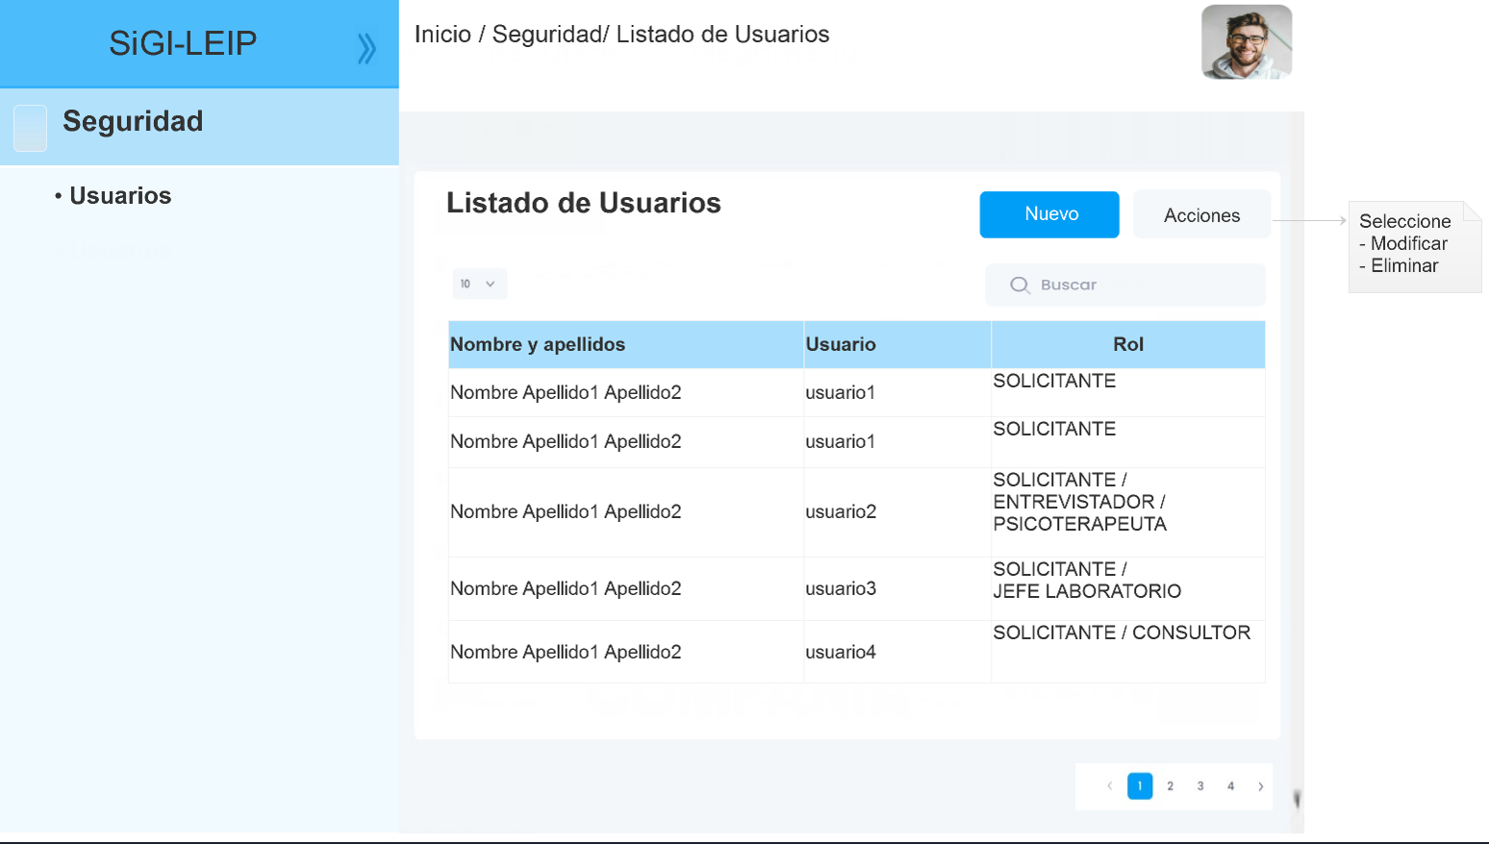

UH2: Add user.

|  |  |
| --- | --- |
|  |  |

**Module Management of Nomenclatures:**

UH1: List Nomenclatures (Bachelor's Degree, Degree, Family Income, Institutions of Psychological Attention).

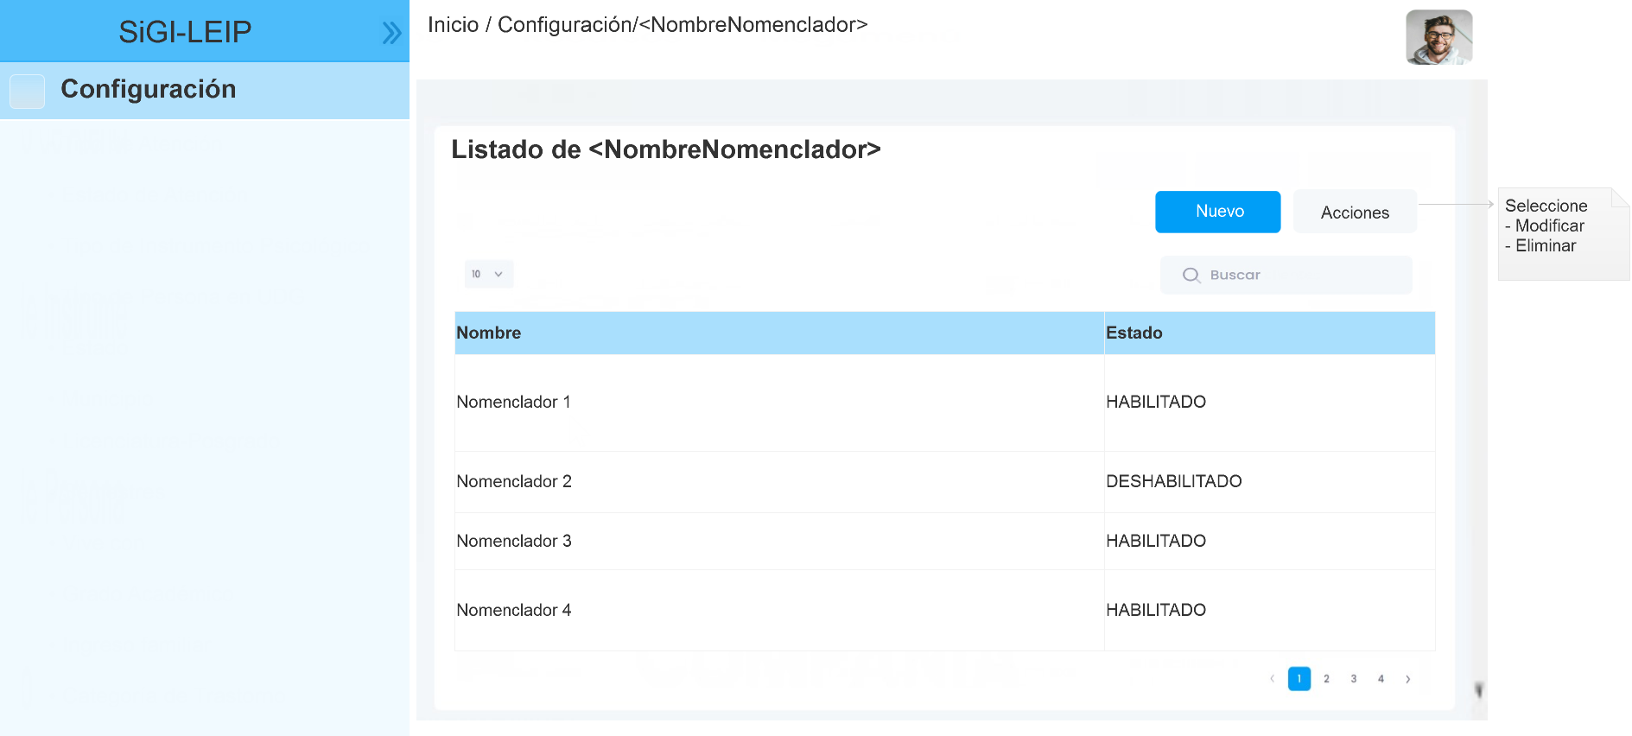

**Module Management of Laboratories LPAI:**

FR1: List Laboratories LPAI.

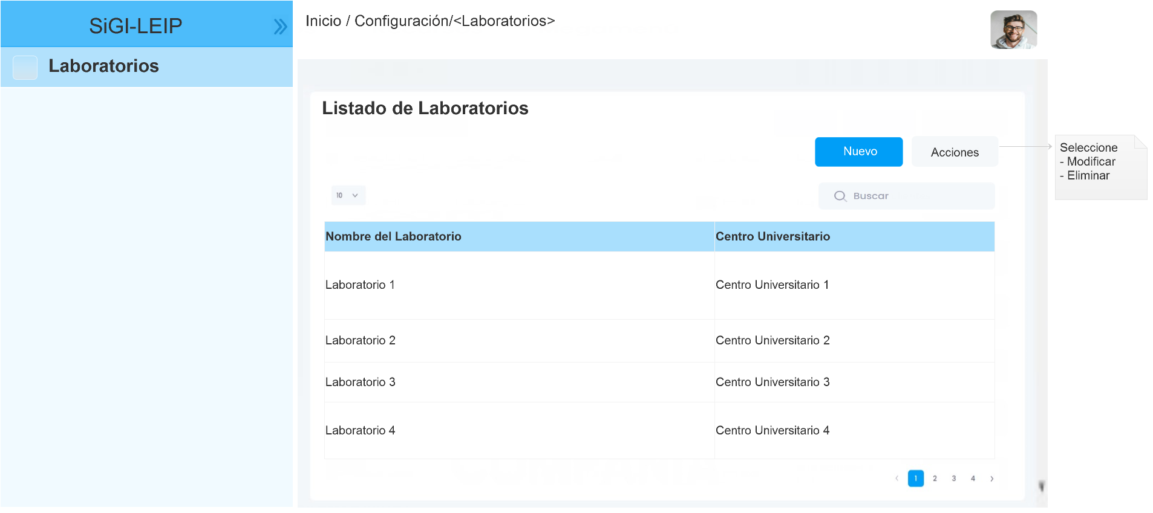

**Module Psychological Assessment and Follow-up:**

UH1: List Psychological Attention.

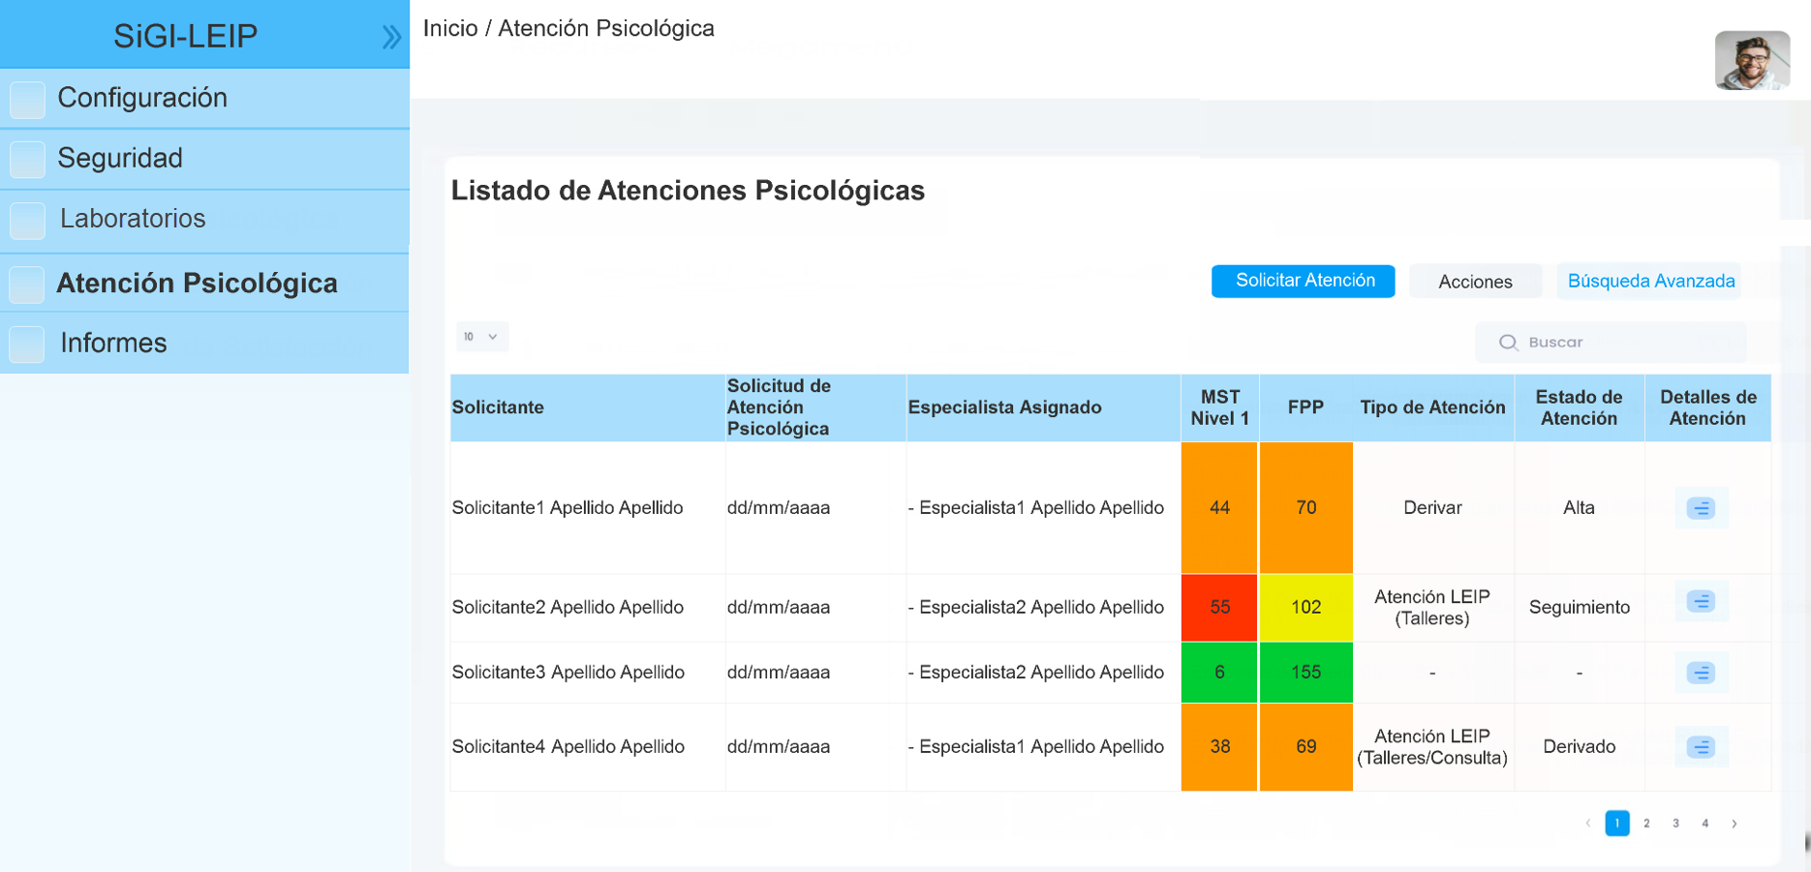

UH2: Register Type of Attention indicated to the patient (Refer, Workshops, Consultations).

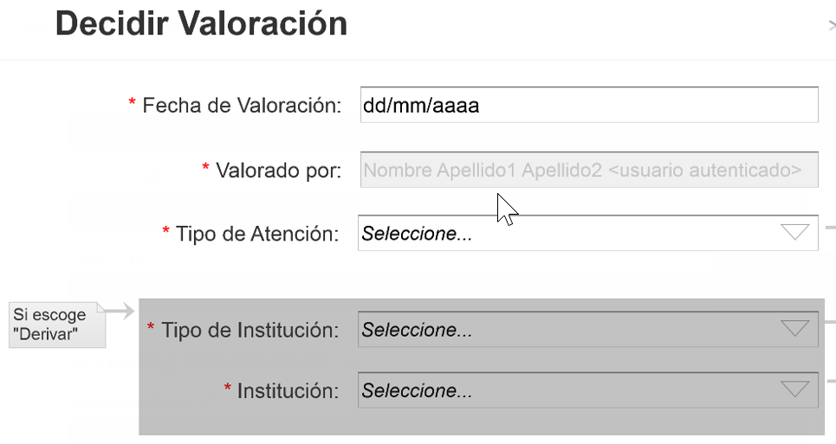

UH3: Register Patient Attention Status (Follow-up, Discharge, Discontinuation).

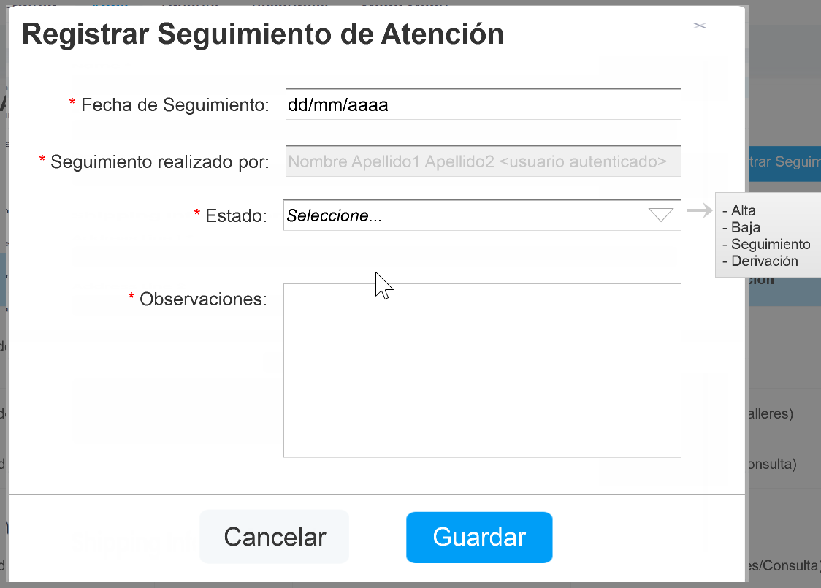

**Module Reports:**

UH1: Generate a report with the total number of patients attended per Bachelor of a University Center.

UH2: Generate reports with the total number of patients attended by Specialists at a University Center.

UH3: Generate a report with the total number of patients evaluated by Type of Attention of all University Centers.

UH4: Generate a report with the total number of patients by their Attention Status of all University Centers.

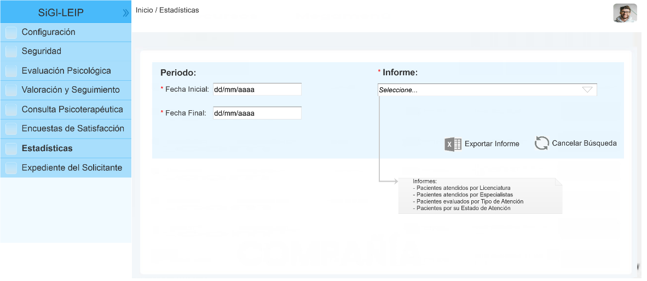

|  |  |
| --- | --- |
|  |  |
|  |  |
|  |  |

2.2.2 The architectural aspects

2.3 Database

2.3.1 Entity-Relationship Diagram

2.4 Source Code

2.5 Acceptance Testing Design

3. Configuration Control

This section describes the process for managing changes in the configuration and deviations from the defined baseline. Procedures are established to control and track the implementation of these changes.

3.1 Decision Making Policy

The decision-making policy in configuration control of a project is fundamental to establish a framework for decision-making related to change requests. This policy defines who has the authority to approve or reject changes, how proposed changes are evaluated, and what criteria are used for decision making.

3.1.1 Authority and Responsibilities

* Define who has the authority to approve or reject changes in the system configuration.
* Assign clear responsibilities to each team member regarding the submission and evaluation of changes.

|  |  |
| --- | --- |
| **Committee Change Control** | |
| **Rols** | **Responsibilities** |
| Manager | Has the final authority to approve or reject changes.  Coordinate committee meetings and ensure that established objectives are met. |
| Project Manager | Responsible for presenting and coordinating the evaluation of changes. |
| Technical Leader | Provides technical advice on the feasibility and impact of proposed changes on system functionalities, architecture, and quality assurance. |
| Human Resources Manager | Assess the impact of changes on personnel and organizational structure.  Provide recommendations on how to manage any impact on the project's human team (e.g., new staff hiring or management of staff overtime hours). |
| Finance Manager | Assess the impact of changes on monetary cost and determine their financial feasibility. |

3.1.2 Decision Making Process

Below is detailed how the decision-making process for change requests is carried out. The responsibilities of each member of the change control board in decision-making are included.

|  |  |  |
| --- | --- | --- |
| **Activities** | | **Rol** |
| 1 | * Submit Request | * Client * Project Team |
| 2 | * Review the request and decide whether to record it as a change request * Register the request, if you decided it is a change request. | * Project Manager |
| 3 | * Initially assess the change request to determine its feasibility and relevance, ensuring understanding of its scope and potential impact. | * Project Manager |
| 4 | * Present the change request to the committee for to start your evaluation. | * Project Manager |
| 5 | Technical Analysis:   * Assess the technical feasibility of the change and its impact on the existing architecture and design. * Determine if new tools or technologies are needed to implement the proposed change. | * Technical Leader |
| 6 | Strategic Evaluation:   * Evaluate the strategic impact of the change in terms of business objectives, budget, necessary personnel, and deadlines for fulfilling the change request. | * Manager * Project Manager * Human Resources Manager * Finance Manager |
| 7 | Review and Discussion of Change Requests in the Committee:   * Review and discuss the change request in detail, considering the technical and strategic analyses previously conducted. | * Committee Change Control |
| 8 | Decision Making:   * Make a decision regarding the change request, considering the recommendations and opinions gathered. | * Committee Change Control |
| 9 | Documentation and Communication of Decisions:   * Document the decision made during the committee meeting. * Communicate the decision to all relevant stakeholders. | * Project Manager |
| 10 | Follow-up and Implementation Supervision:   * Supervise the implementation of the change (if approved), ensuring it is carried out as planned and objectives are achieved. | * Manager * Project Manager |

3.1.3 Decision making criteria

The decision-making process in a project is based on key criteria that guide the evaluation of proposed changes. These aspects are fundamental to ensure that the decisions made are aligned with the project's objectives.

* Technical feasibility: Assess whether the proposed change is technically feasible and compatible with the existing architecture and design of the system.
* Strategic impact: Consider how the change will affect the project's business objectives, including budget, schedule, and required resources.
* Relevance and priority: Determine the importance and urgency of the change in relation to other project objectives and activities.
* Associated risks: Analyze the potential risks and negative consequences of the change, as well as available mitigation measures.
* Expected benefits: Evaluate the potential benefits that the change will bring to the project and whether they justify the resources required to implement it.
* Financial feasibility: Assess whether the project has the necessary financial resources to effectively carry out the change.

4. Change Requests

4.1 Change request #1

The client wants to make profit from the system you are developing. He requested that the system should have a module that retrieves the statistics from a series of branches across the country.

4.1.1 Change request evaluation

The change request affects the following configuration items:

* The Requirements Specification Document: new functionalities will be added (Obtaining statistics associated with types of attention and patient follow-up).
  + A module was added: “Management of Laboratories LPAI”. This module contains 5 functional requirements (list, add, modify and delete information from the laboratories).
  + The "Reports" module was modified. The scope of the functional requirement "FR3" was modified (the quantity must be obtained for all University Centers) and a new functional requirement "FR4" was added (the total number of patients by their Attention Status of all University Centers).
* The System Design Document: new classes must be created for subsequent implementation.
* Source code: New classes with their methods must be implemented.
* Database: New tables and their relationships. Implement new procedures to obtain the new reports.
* Acceptance Testing Document: New test cases must be designed to validate the new functionalities.

This change impacts the baseline, causing an impact on the duration and final cost of the project.

* The duration of the project will be extended by 1 month (20 Work days).
  + Initial duration of the project: 4 months (80 Work days).
  + Current project duration: **5 months (100 Work days).**

The following table details the calculation of the time necessary to develop Change Request #1.

|  |  |  |  |  |  |
| --- | --- | --- | --- | --- | --- |
| **Functionalities** | **Requirements Specification Document** | **System Design Document** | **Database** | **Source code** | **Acceptance Testing Document** |
| **Time (Days)** | | | | |
| Module Management of Laboratories LPAI  (Add 5 functional requirement) | 1 | 2 | 1 | 4 | 2 |
| Module Reports  (Modified FR3) | 1 | 1 | 2 |
| Module Reports  (Add FR4) | 1 | 1 | 4 |
| **Change request #1** | 1 | 4 | 3 | 10 | 2 |
| **20 Days**  **(1 month)** | | | | |

* The cost of the project will increase, it is necessary to pay 1 more month of work to the team.
  + Initial project cost: 235680 MXN
  + Current project cost: 235680 MXN + 58920 MXN = **294600 MXN**

The following tables detail the cost calculation associated with Change Request #1.

|  |  |  |  |
| --- | --- | --- | --- |
| **Roles** | **Configuration items** | **Daily Salary  (Mexican coin)** | **Change request #1 (Days - Salary)** |
| Analyst | Requirements Specification Document | 2000 MXN | 1 Day  2000 MXN |
| Architect | System Design Document | 2700 MXN | 4 Days  10800 MXN |
| Developer | Database, Source code | 2500 MXN | 13 Days  32500 MXN |
| Tester | Acceptance Testing Document | 1900 MXN | 2 Days  3800 MXN |
| Total Salary | | | 49100 MXN |
| 20 %  Other expenses (Electricity, Rent, Office Supplies and other expenses) | | | 9820 MXN |
| **Total Cost** | | | **58920 MXN** |